EXPT NO: 8 | GENERATION OF SYNTHETIC IMAGES USING A GENERATIVE ADVERSARIAL NETWORK (GAN)
DATE: 1/11/26

PRE-LAB QUESTIONS (PROVIDE BRIEF ANSWERS TO THE FOLLOWING QUESTIONS)

1. Discuss the roles of the Generator and Discriminator in a GAN.
A GAN consists of two neural networks:
1. Generator (G):
- Creates fake or synthetic images using random noise.
- Tries to generate images that look like real images.
- Its main goal is to fool the Discriminator.
2. Discriminator (D):
- Checks whether an image is real or fake.
- Receives both real images and generated images.
- Tries to correctly identify fake and real images.
Example: The Generator creates a fake human face, and the Discriminator checks whether it is real or fake.

2. Explain how a Generator produces synthetic images from random noise.
The Generator creates artificial images using random noise.
Steps:
- Random noise is given as input to the Generator.
- The Generator processes the noise through neural network layers.
- It converts the noise into image features.
- These features are combined to create a synthetic image.
- The generated image is sent to the Discriminator for checking.
Example: Random noise is converted into a new artificial image of a cat.

3. Why is adversarial training important in a GAN?
Adversarial training is important because the Generator and Discriminator compete with each other to improve their performance.
- The Generator tries to create realistic fake images.
- The Discriminator tries to identify fake images correctly.
- Both networks learn from their mistakes.
- The Generator gradually produces more realistic images.
- Finally, the generated images become difficult to distinguish from real images.
Example: Like a competition between a fake-money creator and a detective who identifies fake money.

4. Discuss the significance of the loss functions used to train the Generator and Discriminator.
Loss functions measure how well the Generator and Discriminator perform during training.
1. Generator Loss:
- Measures how well the Generator fools the Discriminator.
- A lower Generator loss generally means it is producing images that the Discriminator classifies as real.
2. Discriminator Loss:
- Measures how correctly the Discriminator identifies real and fake images.
- A lower Discriminator loss generally means it is correctly classifying the images.
Significance:
- Helps improve the performance of both networks.
- Reduces errors during training.
- Helps the Generator create realistic images.
- Maintains competition between the two networks.
Conclusion: Loss functions help both networks learn and improve the quality of generated images.

AIM

To implement and train a Generative Adversarial Network (GAN) to generate synthetic images by training a Generator and a Discriminator in an adversarial learning framework.

SOFTWARE REQUIREMENTS
- Python
- TensorFlow / Keras / PyTorch
- Google Colab
- GitHub
- NumPy
- Matplotlib
- Pandas
- Scikit-learn

OBJECTIVES

Students will be able to:

- Understand the architecture and working of Generative Adversarial Networks.
- Identify the functions of the Generator and Discriminator.
- Prepare image datasets for GAN training.
- Generate random noise vectors as inputs to the Generator.
- Build and train a simple GAN using a suitable dataset.
- Understand adversarial training and the associated loss functions.
- Generate synthetic images and visualize the results.
- Evaluate the quality and diversity of generated images through visual inspection.
- Document the experiment and manage the notebook using GitHub.

PROCEDURE
PART A: DATASET PREPARATION
Perform the following tasks:
- Load an image dataset, such as MNIST, and display sample images.
- Explore the image dimensions and pixel-value range.
- Normalize and reshape the images according to the GAN input requirements.
- Prepare batches of real images for training.

CODE :
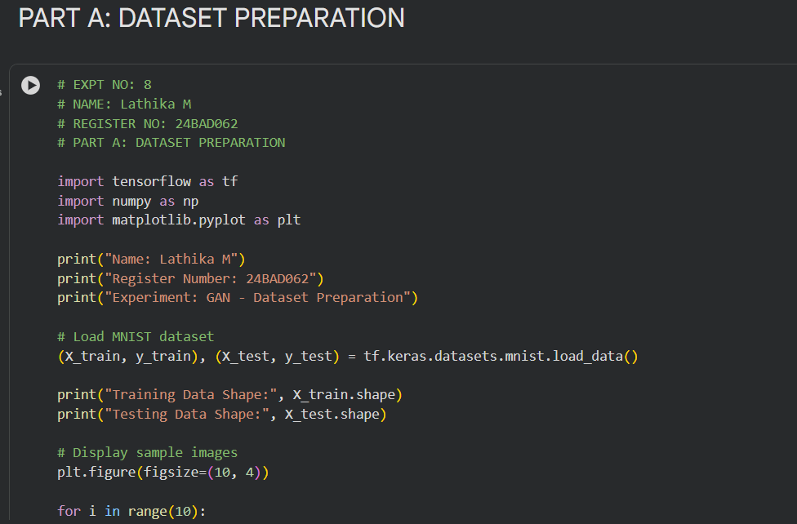

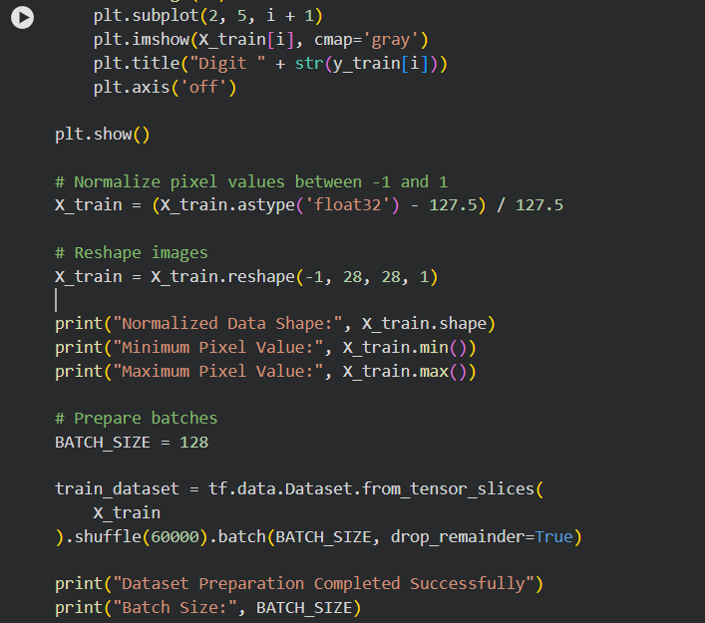

OUTPUT :

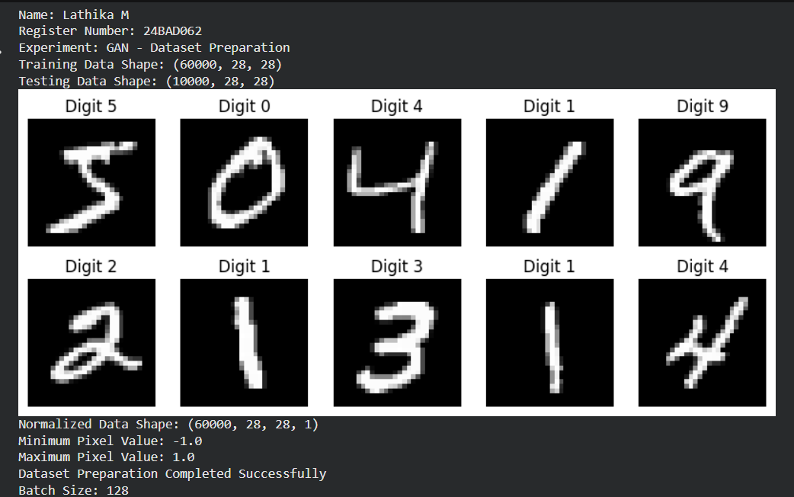
PART B: IMPLEMENTING THE THE GENERATOR AND DISCRIMINATOR
Perform the following tasks:
- Build a Generator model to create synthetic images from random noise vectors.
- Build a Discriminator model to classify images as real or generated.
- Select suitable layers, activation functions, optimizer, and loss function.
- Combine the Generator and Discriminator to construct the GAN.
- Display the model summaries.

CODE :

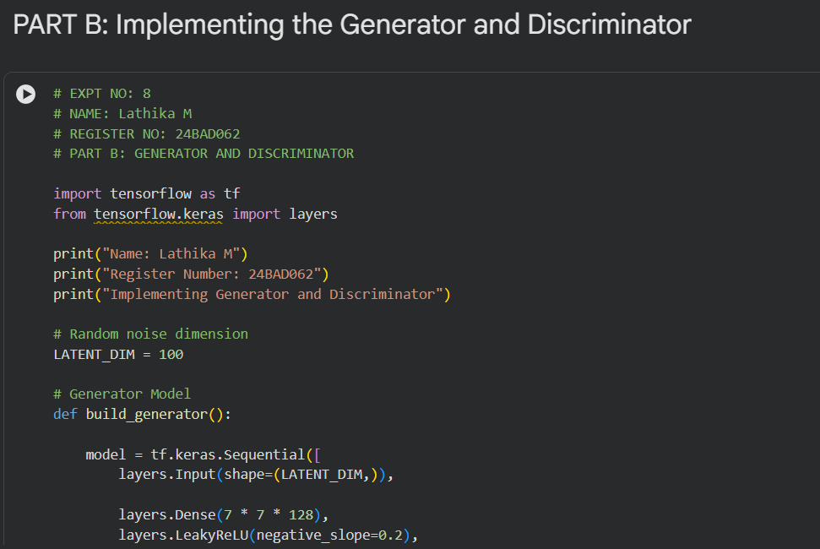

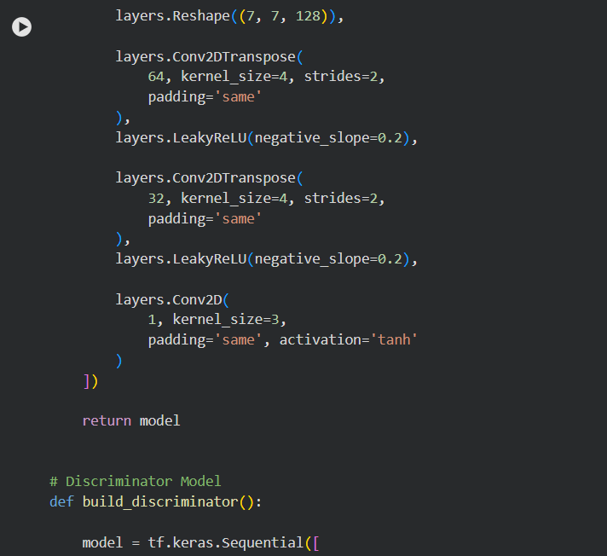

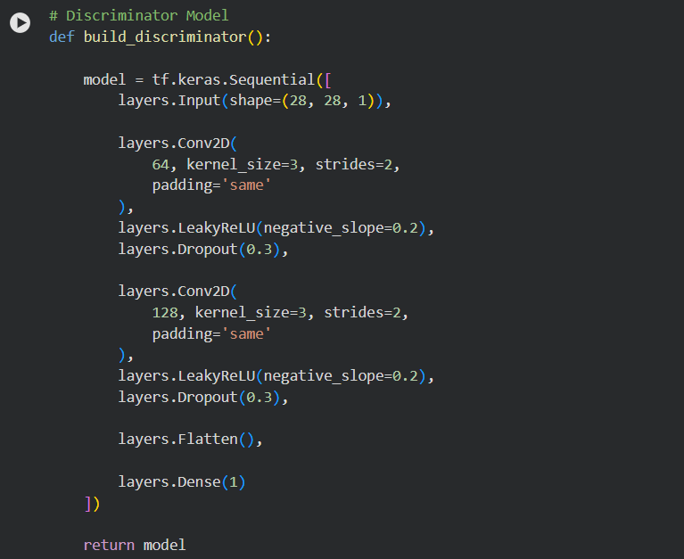

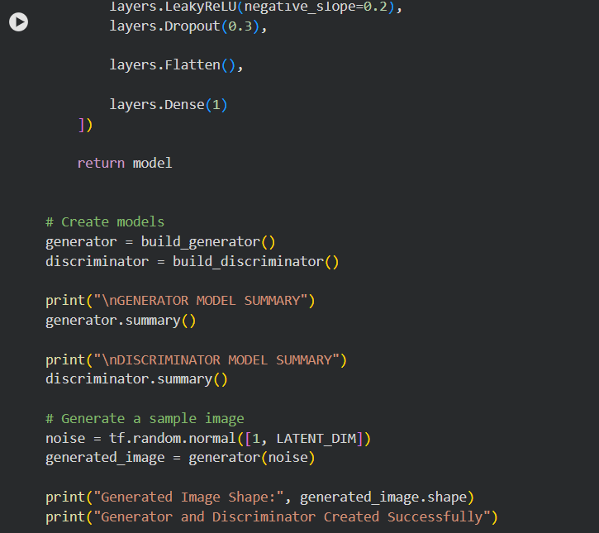

OUTPUT :

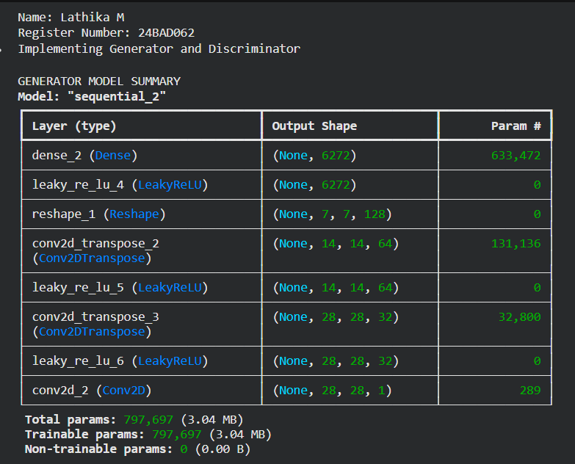
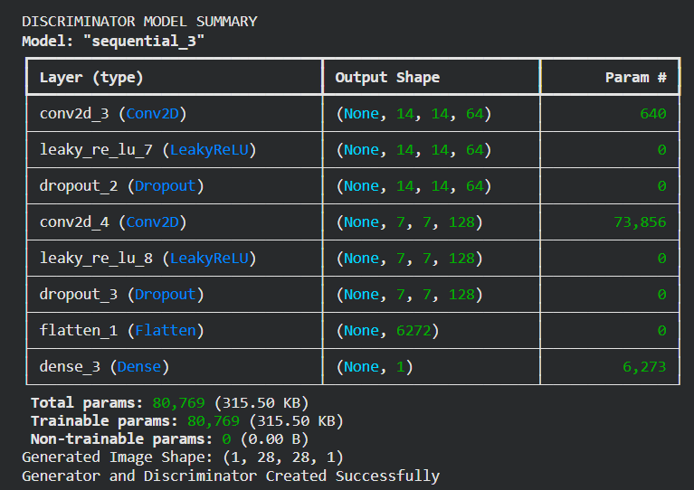

PART C: GAN TRAINING AND PERFORMANCE MONITORING

Perform the following tasks:
- Train the Discriminator using real and generated images.
- Train the Generator to produce realistic images.
- Alternate the training of both models for a suitable number of epochs.
- Record and plot Generator and Discriminator losses.
- Display sample generated images during training.

CODE :

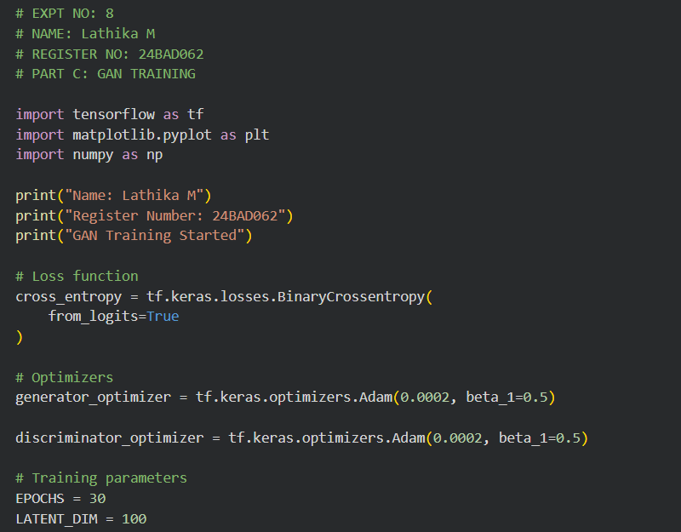

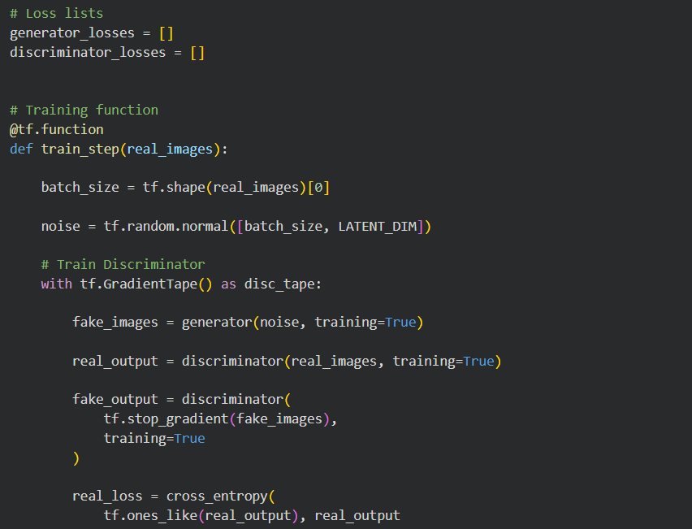

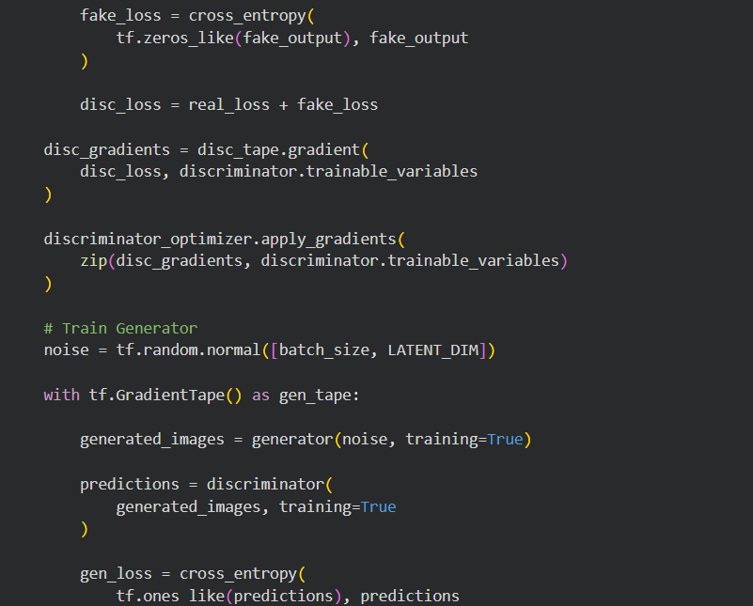

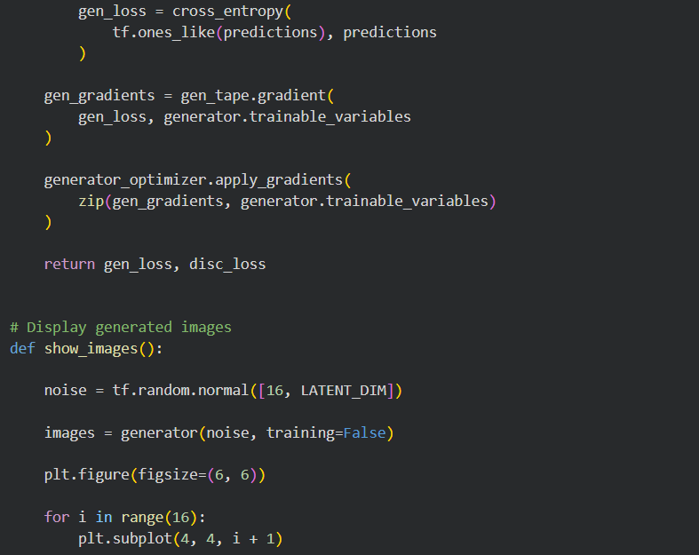

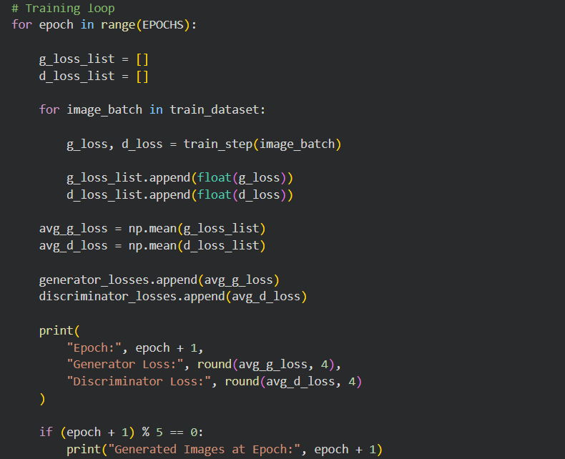
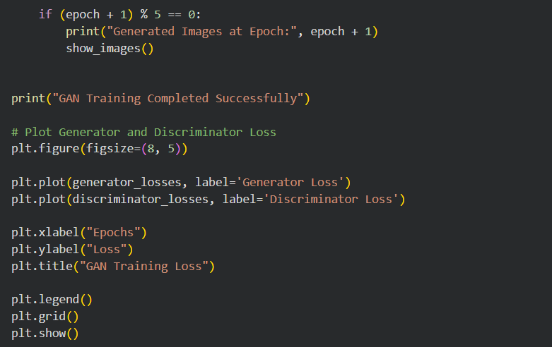

OUTPUT :

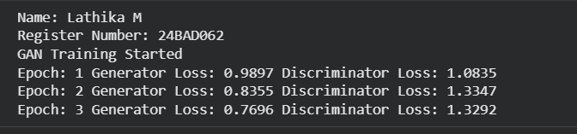

PART D: DIMENSIONALITY REDUCTION, FEATURE VISUALIZATION AND EXPERIMENT MANAGEMENT

Perform the following tasks:
- Provide new movie-review sentences as input to the trained LSTM model.
- Extract latent-space representations of test samples using the trained Encoder.
- Generate synthetic images using the trained Generator.
- Display and compare generated images with original dataset samples.
- Observe the quality, diversity, and recognizability of generated images.
- Document the experiment and upload the notebook to GitHub.

CODE :
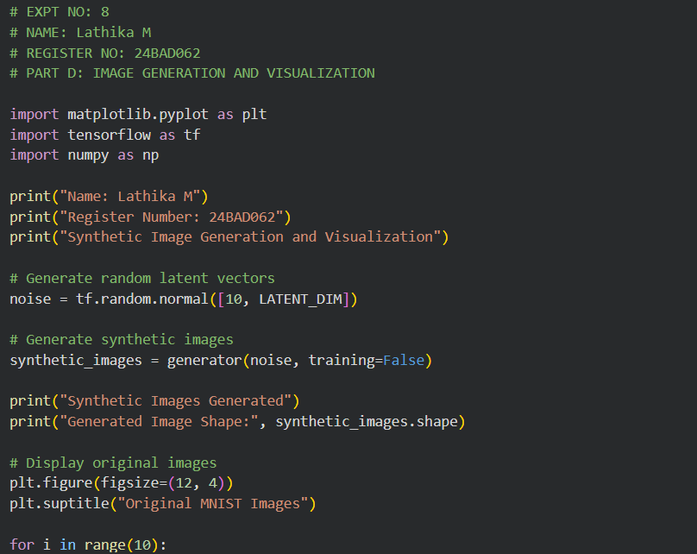
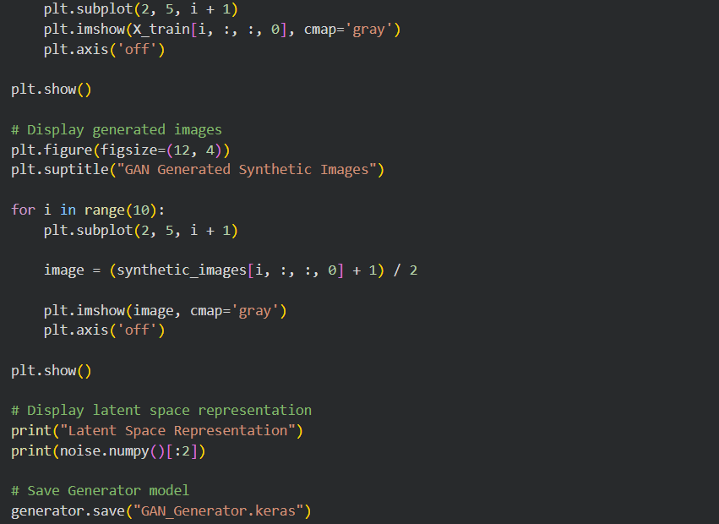

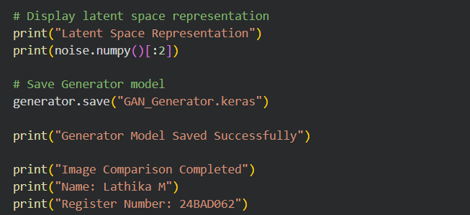

POST-LAB QUESTIONS (PROVIDE BRIEF ANSWERS TO THE FOLLOWING QUESTIONS)

1. Discuss how the quality of generated images changes as GAN training progresses. Explain why a GAN may generate repetitive or low-quality images.
As GAN training progresses, the quality of generated images gradually improves.

Changes in Image Quality:

- Initial Stage: The Generator produces unclear and random images.
- Learning Stage: The Generator starts learning patterns and features from real images.
- Improvement Stage: Generated images become clearer and more realistic.
- Final Stage: The Generator produces images that look similar to real images.

Reasons for Repetitive or Low-Quality Images:

- Mode Collapse: Generator produces the same type of images repeatedly.
- Poor Training: Insufficient training affects image quality.
- Unbalanced Networks: Generator or Discriminator becomes too powerful.
- Insufficient Data: Less training data reduces image variety.
- Wrong Parameters: Incorrect learning rate affects training.
Example: A GAN trained on human faces may repeatedly generate similar-looking faces instead of different faces.

2. Differentiate between the Generator loss and the Discriminator loss.
Generator Loss:

- Measures how well the Generator fools the Discriminator.
- It tries to generate realistic images.
- Lower loss generally indicates better performance against the Discriminator.
Discriminator Loss:

- Measures how correctly the Discriminator identifies real and fake images.
- It tries to classify real and fake images correctly.
- Lower loss generally indicates better classification performance.
Difference:

Generator Loss | Discriminator Loss
Creates realistic fake images. | Identifies real and fake images.
Tries to fool the Discriminator. | Tries to detect fake images.
Focuses on image generation. | Focuses on image classification.

3. Discuss two real-world applications of GANs apart from handwritten digit generation.
1. Medical Image Generation:
- GANs generate artificial medical images such as X-rays and MRI scans.
- They help increase training data for medical research.
- They support the development of disease detection systems.
2. Face Image Generation:
- GANs create realistic human face images.
- They are used in animation, gaming and digital media.
- They can generate different facial expressions and appearances.
Conclusion: GANs are useful in healthcare, entertainment, image generation and many other real-world applications.

ASSESSMENT
Description | Max Marks | Marks Awarded
Pre Lab Exercise | 5
In Lab Exercise | 10
Post Lab Exercise | 5
Viva | 10
Total | 30
Faculty Signature

